Providing safe, reliable transport for the frail aged, younger people with disability and their carers

Application Pack

Application Pack

Job title: | Driver
Reporting to: | Manager, Consumer Engagement
Responsible For: | To provide support for older people and people with disability to access trusted and reliable community services.
Award: | Passenger Vehicle Transportation Award, 2010
Level | Grade 3
Location: | Mortdale
Hours per week: | Casual

Thank you for your interest in St George Community Transport.

Our application pack is designed to assist you with information that will support your decision making regarding this position and also ensuring your application is tailored to our organisation.
It contains the following documents:

- Our selection process and key policy areas
- A position description
- An application form
- Our Organisational Chart
- Our Mission
- Our history
- Our region
- Our Code of Behaviour & Confidentiality Procedure

Additional information about St George Community Transport can be found on our website www.stgct.org.au

Please do not hesitate to contact Human Resource department at St George Community Transport if you have any questions or queries about your application on 9585 3000 or via email amalia.betihavas@stgct.org.au

Selection of Merit

All appointments to St George Community Transport are based on merit i.e. each application is assessed on merit against knowledge, skills, experience, qualification and standard of work performance identified in the position description and advertisement.

The applicant who demonstrates the strongest fit against these selection criteria in their application and throughout the selection processes is recommended to the position.

The Application

In the Advertisement we have outlined the responsibilities, location and selection criteria of the position, which are documented in the Position Description as the knowledge, skills, abilities and experience that are required to perform the duties of the position.

Your application must address the essential and desirable criteria indicated in the position description. If you do not meet the essential requirements specified in the advertisement, or cannot clearly demonstrate that you meet the requirements, you will not be considered for the position. It is your responsibility to ensure this is clearly addressed in your application.

All applications will be held confidential and will be assessed for suitability after the closing date for applications.

To apply please address your application, marked CONFIDENTIAL to:

Human Resources
St George Community Transport
1/29-33 Pitt Street
MORTDALE NSW 2223
Or send to
Amalia.Betihavas@stgct.org.au

The Selection Panel

The selection panel is responsible for selecting the applicant best suited for the position. The selection is based on merit and must be based on the materials presented in writing, at interview and from references. The selected candidate will be the one who best satisfies the selection criteria.

Position Description

Job title: | Driver
Reporting to: | Manager, Consumer Engagement
Responsible For: | Safe and professional transport of clients
Award: | Passenger Vehicle Transportation Award 2010
Level: | Grade 3
Location: | Mortdale
Hours per week: | Varied / or as per contracted

OPERATING ENVIRONMENT
St George Community Transport (STGCT) is a not-for-profit organisation that is committed to improving the lives of its customers, by encouraging and facilitating their mobility, independence and sense of community.

STGCT is funded by Transport for NSW under the Commonwealth Home Support Program and the NSW Community Transport program.

PURPOSE OF THE POSITION
Provide safe, reliable and comfortable transport for all clients, in accordance with the service’s policies and procedures and complying with all traffic and related legislation.

RESPONSIBILITIES
- Drivers are responsible for operating the vehicle in a way that ensures the safety of themselves, their passengers and the public. Drivers are required to do this in a manner that abides with Roads and Maritime, Transport for NSW and the organisation’s operational and safety requirements.

- Provide door-to-door service and assist clients to access and exit the vehicle (including using the wheelchair hoist).

- Ensure client safety and well-being by ensuring that all seatbelts and /or wheelchair / walker restraint systems etc. and equipment/parcels are secured.

- Report any observed changes in client behaviour or challenging behaviour to the service delivery team

- Drive in accordance with run sheets, or as altered on the day, as close as possible to schedule. Provide confirmed or amended information on run sheet to the service delivery team.

- Drive any vehicle economically and carefully in accordance with relevant road laws and policies.

- Adhere to STGCT Work Health & Safety policies, procedures & safety instructions.

- Be responsible for any or all of the following: cash, fares/fees and giving correct change.

- Complete vehicle Pre-departure and end of shift checks.

- Configure the vehicle to meet the needs of the client/groups

- Take all necessary pre-cautions to prevent damage to service vehicles and equipment including phones, tablets, fuel cards, uniform, first aid kits, umbrellas, tool kits.

- Restocking your vehicle of any items it requires such as First Aid or cleaning products.

- Report all accidents/incidents. This includes completing accident report forms and incident reports as required.

- Report any damage, defect or repairs needed to the vehicle in the defect book stored at the office/depot.

- Report to management any person you believe is under the influence of a drug and/or alcohol.

- Report any matters relevant to the currency of your driver’s licence or driver authority to your manager (including traffic offences and criminal charges).

- Report to your manager any health or other issue that may affect your fitness to drive.

- Ensure vehicle is clean, tidy and appropriate for client use at all times

- Wear all safety gear issued including fluorescent vests, hats and appropriate footwear.

- Participate in training, staff meetings and performance reviews as required.

- Do not perform your duties if you are under the influence of alcohol or drugs. Please refer to relevant policies and procedures.

- Any other tasks relevant to the role as directed by the Manager

SELECTION CRITERIA
Mandatory qualifications
- Cleared National Criminal History record check (verified every three years).
- Valid Working with Children Check.

Essential experience or skills
Qualifications
- LR licence
- Satisfactory safe driving record (verified every three years).
- Drivers Authorisation - or willingness to complete during probationary period.
- Current First Aid Certificate – or willingness to obtain prior to commencement of role.
- Pass a health assessment, equivalent to bus and taxi drivers.
Skills
- Safe and experienced driver,
- Well-developed written and verbal communication skills,
- Excellent time management skills to achieve effectiveness in managing conflicting priorities and meeting deadlines;
- Well-developed people and relationship skills with proven ability to work in a team environment communicating and motivating effectively at all levels of the organisation, contributing to a positive work environment, and
- Excellent administration skills including ability to complete log sheets and vehicle inspections.
Knowledge
  - Detailed geographical knowledge of the area including major local landmarks,
  - Detailed knowledge or the ability to quickly acquire knowledge of the organisation’s objectives, goals, policies and procedures.
Experience
  - Four (4) years of proven experience in a similar role or in a position with a similar skill set, and
  - Proven experience to effectively communicate with people with disability and their carers.

PERSONAL ATTRIBUTES
- Honest and trustworthy
- Cultural awareness and sensitivity
- Flexible and patient attitude
- Excellent communication skills
- Flexible & responsive

ORGANISATIONAL VALUES

Safety
We commit to prioritising the safety of our clients when travelling or while they are receiving services at home and in the community. All staff undergo appropriate training, and we are constantly assessing our procedures to see where there are opportunities for improvements.

Respect
We foster a collaborative environment that respects and encourages the contributions of staff, volunteers, and clients. All contributions are valued equally, and we work hard to achieve the best outcome for all involved.

Integrity
We are governed by our Board, which leads our compliance with the legislation and standards under which we operate. The risks faced by our business and our financial stability are overseen by our Board.

Teamwork
We know that we can achieve more when we work together. We embrace diversity, encourage open communication, and share decision-making.

Excellence
We work to continuously improve our service offering and provide our community with the resources they need to make positive choices in their lives.
We encourage excellence in our team members and reward those who display the ability to go above and beyond.

Acknowledgement
I have read and received instruction on the above Job Description and agree to abide by the responsibilities outlined.

Employee Name: Employee Signature: Date:

__________________________ __________________________ _____________

Managers Signature: __________________________ Date: _____________

Application Form – Driver Casual

PERSONAL INFORMATION
Surname: |  |  |  | First Name:
Address:
Suburb: |  |  | State: |  | Post Code:
Date of Birth:
Phone Number: |  |  |  | Mobile:
Email:

QUALIFICATIONS EDUCATION & TRAINING
QUALIFICATIONS | LEVEL ACHIEVED: | DATE COMPLETED

SELECTION CRITERIA
Please select the option which best describes your current residency status:
☐ I am an Australian Citizen or permanent resident
☐ I am a New Zealand Citizen
☐ I have a valid work permit or visa
☐ I do not have a valid work permit or visa
☐ I am eligible for sponsorship nomination

Do you hold a current NSW drivers Licence LR or higher? | ☐ Yes ☐ No
Do you have a current first aid certificate? | ☐ Yes ☐ No
Do you have a Working with Children Check? | ☐ Yes ☐ No
Do you have a NDIS Worker Check? | ☐ Yes ☐ No
Are you willing to undertake a Medical Assessment? | ☐ Yes ☐ No
Are you willing to undertake in a Functional Capacity Evaluation? | ☐ Yes ☐ No
Do you speak a second languages? ☐ Yes ☐ No

If yes, please specify _____________________________________

EMPLOYMENT HISTORY
Please show most recent employment first. (If these details are included on resume- put ‘see attached resume’)
EMPLOYER | DATES | RESPONSIBILITIES / EXPERIENCE
*additional papers or resume may be added /attached to this application

Do you have any health conditions/disabilities that may impact upon your employment in the position that is the subject of this application?

☐ Yes ☐ No

If so please state them and how these issues may be addressed

REFERENCES:

Please provide names of two work related referees.

Name of referee: |  | Contact Number:

Position of referee
Name of referee: |  | Contact Number:

Position of referee
Drivers Licence Information Disclosure Agreement

St George Community Transport (STGCT) has a commitment to protect and not place at unreasonable risk vulnerable people, members of the communities we serve, the STGCT workforce and anyone who enters a STGCT workplace.
STGCT conducts ongoing Working with Children Checks, Police Checks and Drivers Licence Checks in order to meet this commitment and legislative requirements.
Drivers Licence Check
STGCT conducts ongoing Drivers Licence Checks (DLC), for all drivers, as part of its ongoing duty of care responsibilities concerning road safety as well as to encourage the promotion of good driving practices.
DLC is supported by the Road Transport (Driver Licensing) Regulation 2008.

I, …………………………………… …………………………….…., consent to the following:
- STGCT accessing my records at Transport for NSW ("TfNSW") to obtain the information listed below ("Personal information");
- TfNSW releasing that Personal information to STGCT;
- STGCT using my Personal information for the Permitted Purpose below; and
- STGCT providing this consent form to TfNSW for TfNSW to rely on.

CONSENT  Note: tick yes or no for each | INFORMATION TYPE | PERMITTED USE  Note: in this column insert the purpose that the information will be used for
☐ Yes ☐ No | Confirm I hold a current NSW Driver Licence and the Licence Class
☐ Yes ☐ No | Check my demerit points

I understand that I do not have to give my consent but if I do not give my consent then TfNSW will be unable to provide my Personal Information to STGCT.

Licence number: |  |  | Licence Class:
Licence Card Number *
*This number appears in the top right-hand corner of the licence.

Signed:__________________________________ Date:____________________
NOTE: a fresh signed consent is required each time access is sought to TfNSW records

LICENCE DETAILS:
Details of any advance driver courses completed
Have you ever been refused or disqualified from holding a driver’s license? |  | ☐ No ☐ Yes  (if yes please provide details)
Do you have any medical conditions which may restrict your ability to drive a vehicle? |  | ☐ No ☐ Yes  (if yes please provide detail)

Do you consent to:
- a police check being performed every 3 years
- completing a Prohibited Employment Declaration under the Child Protection (Prohibited Employment) Act
- completing RMS Drivers Licence Check
- Completing a medical assessment
- Completing a Functional Capacity Evaluation (FCE)

should you be selected as the preferred applicant

☐ Yes ☐ No

If born outside of Australia please attach proof of citizenship, permanent residency or proof of legal entitlement to work in Australia.

I declare that the above information and the information contained in my written application letter are true and correct, to the best of my knowledge. I understand that should any of the information supplied by me be found to be false, I am liable for disciplinary action that could lead to my dismissal.

If I am offered employment I agree to:
- protect Service User’s confidentiality;
- respect the rights of team members & Service Users;
- not act beyond the duties of my position; and
- Abide by all policies and procedures set by the Governance Body.

Please ensure you have read all documentation referred to in the Employment Information Package and your application letter addresses all essential & desirable criteria listed in the job description.

Signature Date

Organisational Chart
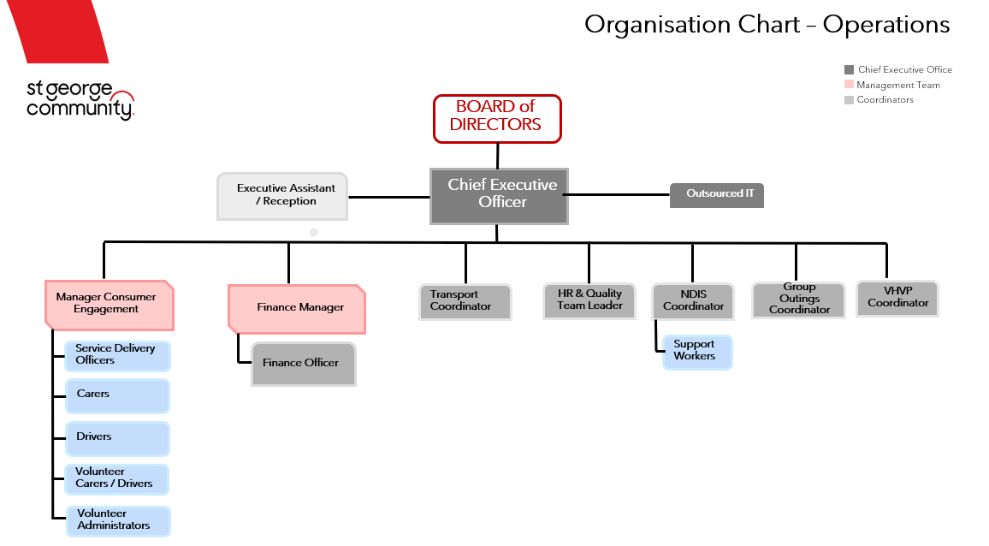

OUR VISION
To facilitate a good quality of life, strong connections and independence for our clients.
OUR MISSION
At St George Community Transport, we strive towards our vision by making the five points below our mission:

Enhance the independence of people in our community
By providing trusted and reliable services across multiple aspects of daily life, our team is dedicated to enabling clients in maintaining their independence both within their personal lives and within the community.

Facilitate people's ability to remain living in their own homes with dignity and choice
The information and services we provide are tailored to each individual client and drive targeted assistance that helps ensure a good quality of life.
We also provide resources for clients, friends, family, and the community which are designed to support our initiatives.

Provide support for vulnerable and disadvantaged individuals
Independence and quality of life are underpinned by being able to access support services that meet each individual's needs. We strive each day to ensure that their needs are met and assist whenever possible.

Foster autonomy and connections
By providing opportunities, information, and a suite of services, we aim to reduce isolation, and help people in our community to exercise their choice and control.

Offer quality, caring service
Care, compassion and experience are required to be a provider of choice within the community services sector, and our team embodies these traits.

OUR VALUES

Safety
We commit to prioritising the safety of our clients when travelling or while they are receiving services at home and in the community. All staff undergo appropriate training, and we are constantly assessing our procedures to see where there are opportunities for improvements.

Respect
We foster a collaborative environment that respects and encourages the contributions of staff, volunteers, and clients. All contributions are valued equally, and we work hard to achieve the best outcome for all involved.

Integrity
We are governed by our Board, which leads our compliance with the legislation and standards under which we operate. The risks faced by our business and our financial stability are overseen by our Board.

Teamwork
We know that we can achieve more when we work together. We embrace diversity, encourage open communication, and share decision-making.

Excellence
We work to continuously improve our service offering and provide our community with the resources they need to make positive choices in their lives.
We encourage excellence in our team members and reward those who display the ability to go above and beyond.

OUR COMMITMENT
St George Community Transport is committed to:
- Ensuring that transport disadvantaged people and organisation’s are aware of the Service and the support it provides;

- Providing opportunities to improve social participation, to maintain or promote a person’s capacity to live as independently as possible.

- Providing a person-centered approach to service delivery, promoting wellness and active participation in goal setting and decision making.

- Providing timely and flexible services that respond to a person and their carer's needs and circumstances.

- Developing collaborative relationships with other service providers for the benefit of people using the service.

- Recruiting and retaining suitable team members to ensure that the service is able to provide an efficient quality service.

- Providing and maintaining an efficient, cost effective and accountable organisation.

Our Region

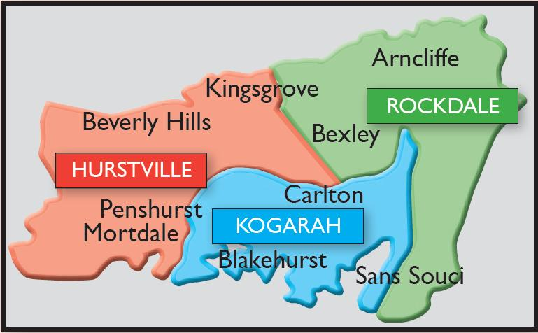

Important region statistics:*
- The region has a total population of 232 000
- Residents over the age of 60 account for more than 20% of the population
- The percentage of clients over the age of 60 is increasing
- More than half the community comes from a non-English speaking background
- Approximately 4.7% of the population has a disability that requires support maintain their independence.

*Source: Australian Bureau of Statistics, 2011 Census

