Providing safe, reliable transport for the frail aged, younger people with disability and their carers

Application Pack

Application Pack

Job title: | Support Worker
Reporting to: | Manager/CEO
Responsible For: | To provide support for older people and people with disability to access trusted and reliable community services.
Award: | Social Community Home Care and Disability Award, 2010
Level | Level 2/ Level 3
Location: | Mortdale
Hours per week: | Casual

Thank you for your interest in St George Community Transport.

Our application pack is designed to assist you with information that will support your decision making regarding this position and also ensuring your application is tailored to our organisation.

It contains the following documents:

- Our selection process and key policy areas
- A Position Description
- Application Form
- Our Organisational Chart
- Our Vision and Mission
- Values and Commitment
- Our region

Additional information about St George Community Transport can be found on our website www.stgct.org.au

Please do not hesitate to contact Amalia Betihavas if you have any questions or queries about your application on 9585 3000 or via email amalia.betihavas@stgct.org.au

Selection of Merit

All appointments to St George Community Transport are based on merit i.e. each application is assessed on merit against knowledge, skills, experience, qualification and standard of work performance identified in the position description and advertisement.

The applicant who demonstrates the strongest fit against these selection criteria in their application and throughout the selection processes is recommended to the position.

The Application

In the Advertisement we have outlined the responsibilities, location and selection criteria of the position, which are documented in the Position Description as the knowledge, skills, abilities and experience that are required to perform the duties of the position.

Your application must address the essential and desirable criteria indicated in the position description. If you do not meet the essential requirements specified in the advertisement, or cannot clearly demonstrate that you meet the requirements, you will not be considered for the position. It is your responsibility to ensure this is clearly addressed in your application.

All applications will be held confidential and will be assessed for suitability after the closing date for applications.

To apply please address your application, marked CONFIDENTIAL to:

Human Resource Department
St George Community Transport
1/29-33 Pitt Street
MORTDALE NSW 2223
Or send to
amalia.betihavas@stgct.org.au

The Selection Panel

The selection panel is responsible for selecting the applicant best suited for the position. The selection is based on merit and must be based on the materials presented in writing, at interview and from references. The selected candidate will be the one who best satisfies the selection criteria.

Position Description

Job title: | Support Worker
Reporting to: | Manager/CEO
Responsible For: | To provide support for older people and people with disability to access trusted and reliable community services.
Award: | Social Community Home Care and Disability Award, 2010
Level | Level 2/ Level 3
Location: | Mortdale
Hours per week: | Casual

OPERATING ENVIRONMENT
St George Community Transport Limited (STGCT) is a not-for-profit Company Limited by Guarantee which operates as a charity. It is currently funded by Transport for NSW as an agent for the Commonwealth Home Support Program and the NSW Community Transport Program.

STGCT was established as a Company Limited by Guarantee in 2018, and provides One on One Social Support and In-Home Services to NDIS participants and a high quality, affordable and appropriate transport service to people 65 years and over, people with disability and their carers who reside within the South East Sydney . Prior to 2018 the organisation was established in 1987 as an Incorporated Association.

PURPOSE OF THE POSITION
The primary purpose of this position is to provide One on One support to older consumers and NDIS participants to assist them to; reach their goals, continue living independently in their own homes and access the community.

Responsibilities
- Support the planning of services and activities to assist the NDIS participant or older person to achieve their goals as per their Service Care Plan. These services will develop their skills associated with daily living and will increase their capacity to be part of a community.
- Perform duties in a manner that promotes the dignity, independence and acquisition of skills of participants.
- Provide culturally respectful and appropriate service delivery.
- Respect the privacy and confidentiality of participants in accordance with privacy legislation and STGCT Policies and Procedures, during and beyond the period of employment.
- Complete all required case notes and related documentation which includes monitoring and documenting activities and goals as part of their STGCT Service Care Plan Support Plan.
- Support consumers and NDIS participants to engage with the community to improve their independence and access to other services.
- Adhere to STGCT WHS Policy & Procedures.
- Perform duties in a manner that supports the consumer and participant’s right to take risks and support them in making these decisions by providing them with relevant information.
- Advise the management team of any concerns of changes in behaviour which may warrant a revised risk assessment..
- Maintain a positive relationship with the consumer and participant’s family/carer/advocate where applicable.
- Report all incidents, accidents and injuries to the Manager/CEO.
- Report all feedback to the Manager/CEO.
- Participate in the performance review process which will entail informal meetings and an annual performance appraisal.
- Communicate regularly with your Manager/CEO.
- Any other tasks relevant to the role as directed by a member of the management team.

SELECTION CRITERIA
Mandatory qualifications
- Cleared National Criminal History record check (verified every three years).
- Working with Children Check (or willingness to obtain)
- Current First Aid Certificate
- NSW Drivers Licence

Essential experience or skills
Qualifications / Experience
- Cert III or IV in Disability or Aged Care (or other community services-based qualifications)
- Previous work experience providing personal care
- Ability to use technology such as smart phones and computers.
- Current unrestricted Australian Drivers Licence.
- Current Vehicle Registration & Current Compulsory Third Party Personal Injury Insurance
- Willing to transport people in their own car
- Willing to work anywhere in South East Sydney.

Skills
- Ability to communicate effectively with older people and people with disability.
- Excellent written and verbal communication skills
- Good time management skills
- Ability to work in a flexible, multi-tasking environment.

Knowledge
- Knowledge and experience /understanding the needs of older people and people with disability.

Desirable experience or skills
- Understanding of the community sector.
- Experience or a good understanding of the provision of community services in a Not-for-Profit environment

PERSONAL ATTRIBUTES
- Honest and trustworthy
- Cultural awareness and sensitivity
- Flexible and patient attitude
- Excellent communication skills
- Flexible & responsive

ORGANISATIONAL VALUES

Safety and Compliance
- We commit to prioritising the safety and wellbeing of our people, participants and those who share the road and adhere to all applicable laws.

Client Focus
- We listen to our consumers and participants and put their needs first.

Acting Ethically
- We operate with honesty, integrity, independence, transparency, equity and fairness.

Valuing Others
- We foster a collaborative working environment that values contribution and recognises and respects the views and rights of all.

Excellence
- We strive to be the best by continuously improving what we do and how we do it, and by sharing our knowledge, skills and ideas.

Teamwork
- We embrace diversity and work together towards our common purpose, communicating freely and sharing decision-making and the tasks involved.

Positive Attitude
- We cultivate positivity and goodwill in our business, personal activities and relationships.

Acknowledgement

Employee Signature__________________________________________Date_____________

Manager Signature___________________________________________Date____________

Performance review period: ________________ Next review date_____________

Application Form – Support Worker Casual

Name: |  | Date of Birth:
Address: |  | Phone:
Email: |  | Mobile:

Education
Secondary level reached:

Tertiary qualifications:

Courses completed relevant to position: |  |  | Level of Training:

Please select the option which best describes your current residency status:
☐ I am an Australian Citizen or permanent resident
☐ I am a New Zealand Citizen
☐ I have a valid work permit or visa
☐ I do not have a valid work permit or visa
☐ I am eligible for sponsorship nomination

Do you hold a current NSW drivers Licence? | ☐ Yes ☐ No
Do you have Current Vehicle Registration & Current Compulsory Third Party Personal Injury Insurance? | ☐ Yes ☐ No
Do you have a current first aid certificate? | ☐ Yes ☐ No
Do you have a Working with Children Check? | ☐ Yes ☐ No

Do you speak a second languages? ☐ Yes ☐ No

If Yes, please specify _____________________________________

Previous Employment. Please show most recent employment first.
(If these details are included on resume- put ‘see attached resume’)

Dates | Employer | Responsibilities

Do you have any health conditions/disabilities that may impact upon your employment in the position that is the subject of this application?

☐ Yes ☐ No

If so please state them and how these issues may be addressed

References: Please provide names of two work related referees.

Name: |  | Phone:
Name: |  | Phone:

Licence Details

Drivers Licence No: |  | Class:

Police Check Consent

Do you consent to a police check being performed every 3 years and completing a Prohibited Employment Declaration under the Child Protection (Prohibited Employment) Act should you be selected as the preferred applicant

☐ Yes ☐ No

If born outside of Australia please attach proof of citizenship, permanent residency or proof of legal entitlement to work in Australia.

I declare that the above information and the information contained in my written application letter are true and correct, to the best of my knowledge. I understand that should any of the information supplied by me be found to be false, I am liable for disciplinary action that could lead to my dismissal.

If I am offered employment I agree to:
- protect Service User’s confidentiality;
- respect the rights of team members & Service Users;
- not act beyond the duties of my position; and
- Abide by all policies and procedures set by the Governance Body.

Please ensure you have read all documentation referred to in the Employment Information Package and your application letter addresses all essential & desirable criteria listed in the job description.

Signature Date

Organisational Chart

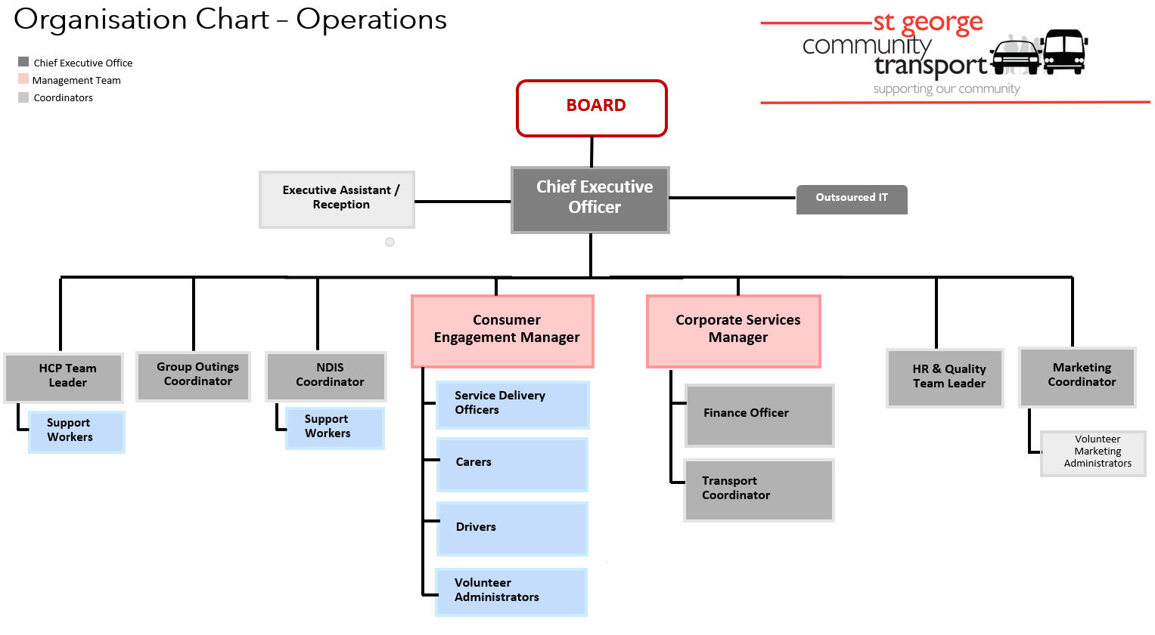

OUR VISION
St George Community Transport will become a leader of excellence in the delivery of Community Transport Services through its ability to foster productive partnerships in the community through the use of its capacity and efficient infrastructure.
OUR MISSION
Is to support the frail aged, people with disability, their carer’s and other transport-disadvantaged people with an efficient and equitable transport service.
OUR VALUES
• Our Clients will be valued as individuals;
• Clients will be assisted to maximize their mobility;
• Clients will be supported to make choices in their own lives;
• Clients will be treated with dignity and respect;
• Access to services is equitable and non-discriminatory;
• The community will be provided with a safe, comfortable and reliable service.
OUR COMMITMENT
St George Community Transport is committed to:
• Ensuring that transport disadvantaged people and organisation’s are aware of the Service and the support it provides;
• Providing opportunities to improve social participation, to maintain or promote a person’s capacity to live as independently as possible;
• Providing a person-centered approach to service delivery, promoting wellness and active participation in goal setting and decision making;
• Providing timely and flexible services that respond to a person and their carer's needs and circumstances;
• Developing collaborative relationships with other service providers for the benefit of people using the service;
• Recruiting and retaining suitable team members to ensure that the service is able to provide an efficient quality service;
• Providing and maintaining an efficient, cost effective and accountable organisation.

Our Region

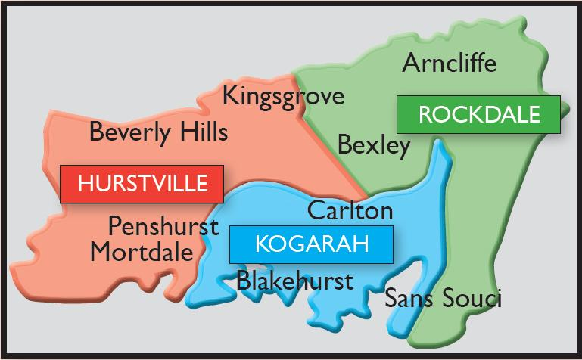

Important region statistics:*
- The region has a total population of 232 000
- Residents over the age of 60 account for more than 20% of the population
- The percentage of clients over the age of 60 is increasing
- More than half the community comes from a non-English speaking background
- Approximately 4.7% of the population has a disability that requires support to be independent

*Source: Australian Bureau of Statistics, 2011 Census

