Providing safe, reliable transport for the frail aged, younger people with disability and their carers

Application Pack

Application Pack

Position: | Carer
Reports to: | Manager Consumer Engagement
Hours: | Casual Role-hours as required.
Award: | SCHADS Level 2
Location: | Mortdale

Thank you for your interest in St George Community Transport.

Our application pack is designed to assist you with information that will support your decision making regarding this position and also ensuring your application is tailored to our organisation.
It contains the following documents:

- Our selection process and key policy areas
- A Position Description
- An Application Form
- Our Organisational Chart
- Our Vision and Mission
- Values and Commitment
- Our region
- Our Code of Behaviour & Confidentiality Procedure

Additional information about St George Community Transport can be found on our website www.stgct.org.au

Please do not hesitate to contact Nurina Simpson, Manager Consumer Engagement St George Community Transport if you have any questions or queries about your application on 9585 3000 or via email nurina.simpson@stgct.org.au

Selection of Merit

All appointments to St George Community Transport are based on merit i.e. each application is assessed on merit against knowledge, skills, experience, qualification and standard of work performance identified in the position description and advertisement.

The applicant who demonstrates the strongest fit against these selection criteria in their application and throughout the selection processes is recommended to the position.

The Application

In the Advertisement we have outlined the responsibilities, location and selection criteria of the position, which are documented in the Position Description as the knowledge, skills, abilities and experience that are required to perform the duties of the position.

Your application must address the essential and desirable criteria indicated in the position description. If you do not meet the essential requirements specified in the advertisement, or cannot clearly demonstrate that you meet the requirements, you will not be considered for the position. It is your responsibility to ensure this is clearly addressed in your application.

All applications will be held confidential and will be assessed for suitability after the closing date for applications.

To apply please address your application, marked CONFIDENTIAL to:

Nurina Simpson
St George Community Transport
70 Roberts Avenue
MORTDALE NSW 2223
Or send to
nurina.simpson@stgct.org.au

The Selection Panel

The selection panel is responsible for selecting the applicant best suited for the position. The selection is based on merit and must be based on the materials presented in writing, at interview and from references. The selected candidate will be the one who best satisfies the selection criteria.

Position Description

Job title: Carer
Reporting to: Manager Consumer Engagement
Salary: SCHADS
Hours: TBC
Location: MORTDALE

Operating Environment
St George Community Transport (STGCT) is a not-for-profit organisation, constituted under the Incorporation Act (NSW) 2009. It is funded by Transport for NSW under the Commonwealth Home Care Support Program (CHSP) and the NSW Community Transport Program.
St George Community Transport Project Inc was established in 1987, to support the frail aged, people with disability, their carer’s and other transport-disadvantaged people with an efficient and equitable transport service.

Purpose of the Position
To provide a safe, supportive and comfortable transport experience for clients.

Responsibilities
- Ensure that clients receive support required to access and/or exit the vehicle, safely and comfortably. (including using the wheelchair hoist)

- Provide support to the driver by ensuring that all seat belts are fastened and other safety procedures adhered to.

- Collecting money from service users for fares etc

- Assisting the service users & driver with loading walkers or shopping bags onto the bus

- Assisting service users by providing companionship and conversation during transportation or whilst on social outings.

- Alert driver to any issue that requires journey to be interrupted

- Report any observed changes in client status/ behaviour or issues to the Service Delivery Team or Manager

- Adhere to STGCT WHS policy & procedures

- Ensure vehicle is clean, tidy and appropriate for client use

- Any other tasks relevant to the role as directed by the Manager

Work experience & skills
Essential | Desirable
Cert III in Home and Community Care  (or other community services based cert)  or relevant work experience | Willingness to gain Cert III in Home and Community Care
Current First Aid Certificate | Understanding of the disability and aged care service environment
Current National Police Check
(or willingness to obtain)
Current Working with Children check
(or willingness to obtain)

Personal qualities & behavioural traits
Essential | Desirable
Well-developed written and verbal communication skills | Ability to work in a flexible, multi-tasking environment
Ability to communicate effectively to people with disability and their carers
Time management skills

Acknowledgement

Employee Signature__________________________________________Date_____________

Manager Signature___________________________________________Date____________

Performance review period:

Next review date__________________________

Application Form

Name: | Date of Birth
Address: | Phone:
Email: | Mobile:

Please indicate which Carer Position/s and/or role you are applying for:
Part-time Position Casual Position *Volunteer role

(*For Volunteer role please use volunteer application form or call the office directly)

Education
Secondary level reached:

Tertiary qualifications:

Courses completed relevant to position | Level of Training

Languages spoken

Previous Employment. Please show most recent employment first.
(If these details are included on resume- put ‘see attached resume’)
Dates | Employer | Responsibilities

Do you have any health conditions/disabilities that may impact upon your employment in the position that is the subject of this application Yes/No
If so please state them and how these issues may be addressed

References: Please provide names of two work related referees.
Name: |  | Phone:
Name: |  | Phone:

Licence
Drivers Licence No: Class:

Do you consent to a police check being performed every 3 years and completing a Prohibited Employment Declaration under the Child Protection (Prohibited Employment) Act should you be selected as the preferred applicant Yes/No

If born outside of Australia please attach proof of citizenship, permanent residency or proof of legal entitlement to work in Australia.

I declare that the above information and the information contained in my written application letter are true and correct, to the best of my knowledge. I understand that should any of the information supplied by me be found to be false, I am liable for disciplinary action that could lead to my dismissal.

If I am offered employment I agree to:
- protect Service User’s confidentiality;
- respect the rights of team members & Service Users;
- not act beyond the duties of my position; and
- Abide by all policies and procedures set by the Governance Body.

Please ensure you have read all documentation referred to in the Employment Information Package and your application letter addresses all essential & desirable criteria listed in the job description.

Signature Date

Organisational Chart

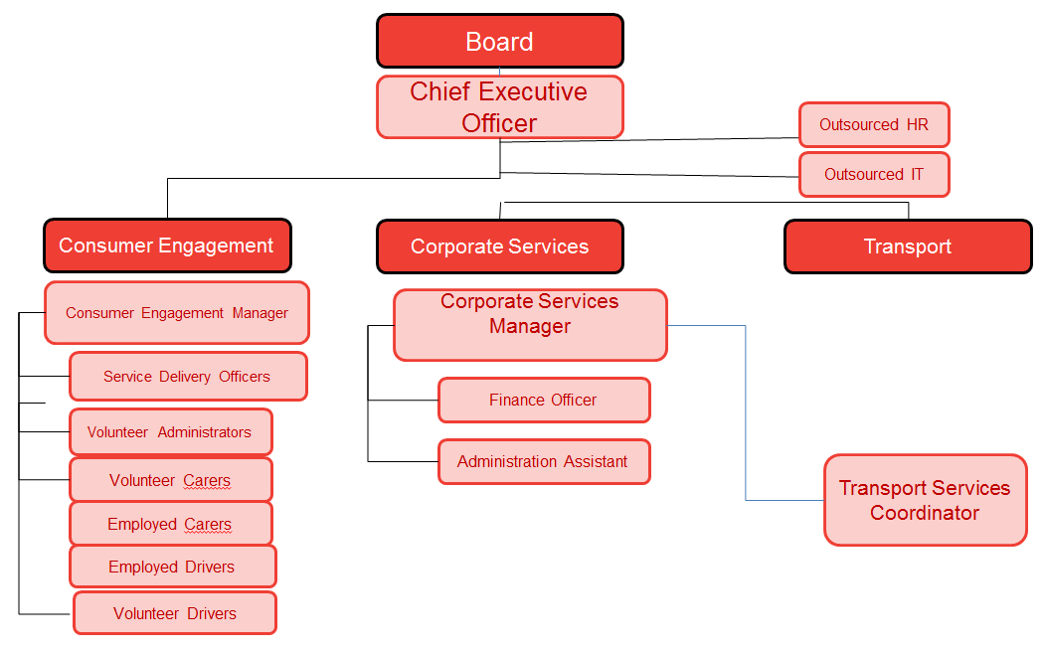

OUR VISION
St George Community Transport will become a leader of excellence in the delivery of Community Transport Services through its ability to foster productive partnerships in the community through the use of its capacity and efficient infrastructure.
OUR MISSION
Is to support the frail aged, people with disability, their carer’s and other transport-disadvantaged people with an efficient and equitable transport service.
OUR VALUES
• Our Clients will be valued as individuals;
• Clients will be assisted to maximize their mobility;
• Clients will be supported to make choices in their own lives;
• Clients will be treated with dignity and respect;
• Access to services is equitable and non-discriminatory;
• The community will be provided with a safe, comfortable and reliable service.
OUR COMMITMENT
St George Community Transport is committed to:
• Ensuring that transport disadvantaged people and organisation’s are aware of the Service and the support it provides;
• Providing opportunities to improve social participation, to maintain or promote a person’s capacity to live as independently as possible;
• Providing a person-centered approach to service delivery, promoting wellness and active participation in goal setting and decision making;
• Providing timely and flexible services that respond to a person and their carer's needs and circumstances;
• Developing collaborative relationships with other service providers for the benefit of people using the service;
• Recruiting and retaining suitable team members to ensure that the service is able to provide an efficient quality service;
• Providing and maintaining an efficient, cost effective and accountable organisation.

Our Region

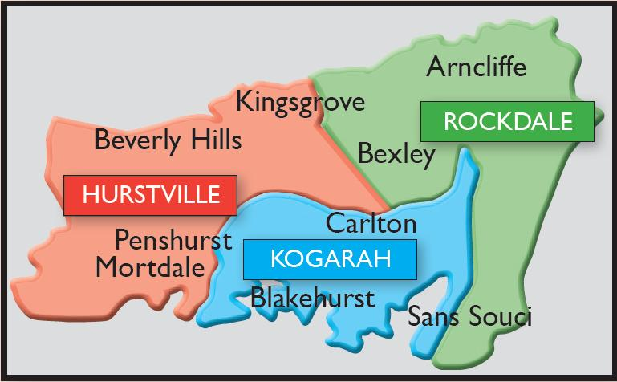

Important region statistics:*
- The region has a total population of 232 000
- Residents over the age of 60 account for more than 20% of the population
- The percentage of clients over the age of 60 is increasing
- More than half the community comes from a non-English speaking background
- Approximately 4.7% of the population has a disability that requires support to be independent

*Source: Australian Bureau of Statistics, 2011 Census

